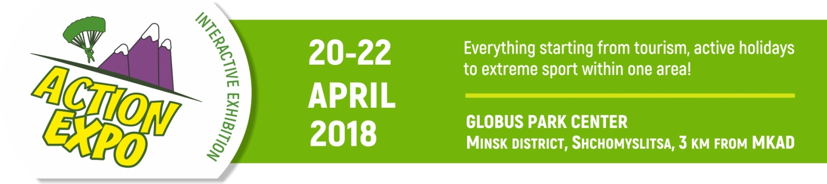
Application form № 1 from «__» of _____________ 201_
Registration number ________
(assigned by the Organizer)
EXHIBITOR Full name of organization (Russian)
EXHIBITOR Full name of organization (English)
Address (legal / postal):
Phone: fax: e-mail:
UNP (Payer's Registration Number): Bank:
IBAN: BIC: SWIFT:
The head of the organization (full name)
Job Position: on the basis of:

Kind of service to provide | Quantity | Price, euro | Sum, euro
Registration fee |  | 100
Exhibition area:
Equipped stand, 1 sq. m. |  | 60
Unequipped area, 1 sq. m. |  | 45
Open exhibition area (outside the pavilion), 1 sq. m. |  | 25
Special offer:
Special offer, equipped stand 4 sq. m. and registration fee |  | 300
Special offer, unequipped area 4 sq. m. and registration fee |  | 250
Location on the fairground, 1 sq. m. |  | 40
Additional services:
Inscription on the frieze (for equipped stands, up to 18 symbols) |  | 20
The cost of each subsequent symbol (for inscriptions over 18 symbols) |  | 1,5
Participating by accreditation of promoter from company with / without stand |  | 130 / 250
All prices are given in EUR, excl. VAT 20% | Total
Inscription on the badge:
3 badges are included in the cost of registration fee
Surname | Name | Middle name
Inscription on the frieze in block letters, 1 symbol for 1 cage (letter, space, dash, comma, etc.)
Supervisor of the stand (full name)
Position: Mobile: e-mail:
Exhibitor: The head of the organization
/signature, full name/ seal

